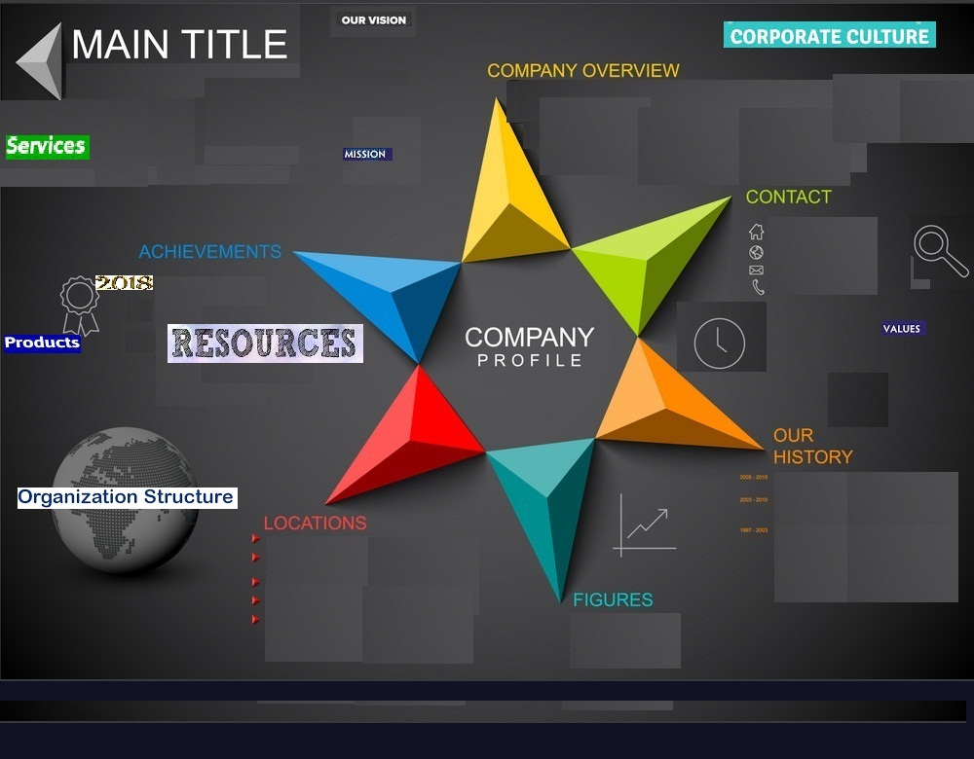
Trustworthy partner
Loyalty, commitment and Honesty
Email: dig@g.biz
Tel: +127417542
Integrity, Respect, Adaptability, team work and Responsibility
Since 2009, Digital group has been providing design services through highly motivated professionals.

Tetu Building state house road
Suit A6
Website design, development, Hosting Services
Digital Group
Web services
Software
Media services
To provide consumers with high quality products and services.
To be the leading company globally
Started in the year 2009.Digital group provide design services.

CEO
Marketing
Infrastructure
Investment
IT, Production, inventory and human skills
Digital Consulting group

